University of Ulster

BSc (Hons) Computing Science

Module: Mobile Technology

**Assignment 1:**

**Advanced App Specification**

Student Name: Leontin Groza

Student Number:

Contents

Introduction 3

Content 3

Description 3

Application Specifications 3

Target Platform Choice 5

Implementation Platform Choice 6

App Design 6

# Introduction

Several aspects of clinical and health practice have been affected with the introduction of mobile devices and applications in different fields of medical and health care. Increased usage of devices has led to a growth in software applications designed specifically for medical use. Several applications are available at this point to assist medical staff in gathering important information such as clinical monitoring, consulting and communications, health data recording with access and several others.

The integration of mobile devices and applications in clinical practice follows the development, quality and availability of software applications designed for medical purposes. At this point medical staff use smartphones to complete task which in earlier times would require a desktop computer, PDA or pager to accomplish.

The extensive use of mobile devices increased the development of evidence-based mobile applications. Apps with an inclination for mental health have a potential to improve the access to treatment. The issue arising is the lack of evidence regarding the efficiency of the apps. Considering the miniature number of studies, the data needs to be analyzed with care, eventually leading to recalling the study.

In present times, governments have been interested in the wellbeing of the population and what matters for the individuals. Traditionally, this has been made via GDP (gross domestic product) but the interests are moving towards the practices and policies that reflect the wellbeing in the decisions made by the individuals.

# Content

### Description

The proposed application will be titled “Emoji Log”. The focus of the application will be to record at request the emotion of the user along with the location, date and time, data that is going to be available for viewing by the user at request. The idea is to make the user aware of the changes in emotion and the minimum factors that led to the change. The user will also be able to enter details at recording, details that will be provided to him at the moment a profile will be build.

### Application Specifications

The requirements in an application ca be divided in functional requirements and no-functional requirements. Functional requirements represent what a system must do, describes how a system must behave.

In terms of functional requirements, the system will give the user several options throughout the process.

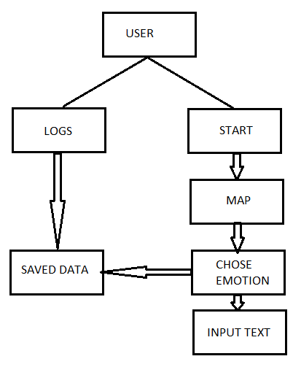

The application will give the user two choices:

- START;

- VIEW LOGS.

By pressing START: - a new view will open;

- the app will establish the exact location of the device;

- the app will get the current date and time;

- the user will be able to see the location of the device on a map.

Location acquired: - a new view will open populated with buttons;

- each button corresponds to a state of emotion;

- once a button pressed, the user will be asked to input additional data;

- the user can choose to input data and SAVE or just to SAVE.

- all the data will be saved in log files.

By pressing LOGS: - the user will be able to see any existing saved data inputted at a past moment.

Non-functional requirements are a representation of the web literature definitions regarding the presentation and aspect of a system. Non-functional requirements denote the constrains where the system must operate.

The aspect of a system is built according to specific guidelines and patterns implemented by the industry. A pattern represents a design of a proven system that incorporates together a problem, context and solution. Guidelines are design build rules created to be applied in a specific context.

The blueprint of the app has not yet been fully completed and the choice of design pattern has not been implemented.

Similar to apps, like “Happyo Mood Tracker”, “Diary mood tracker”, or “Mood Diary” the app “Emoji Log” will keep a simple and easy to use design that will implement the 3 click rule for the user’s best experience. The app will have a minimum number of views, enough to complete the task it has been developed for. The design is minimalist, will include several images, a series of clickable images to select specific moods. The logs will be presented in a simple and understandable way to make the experience quick and simple for the user.

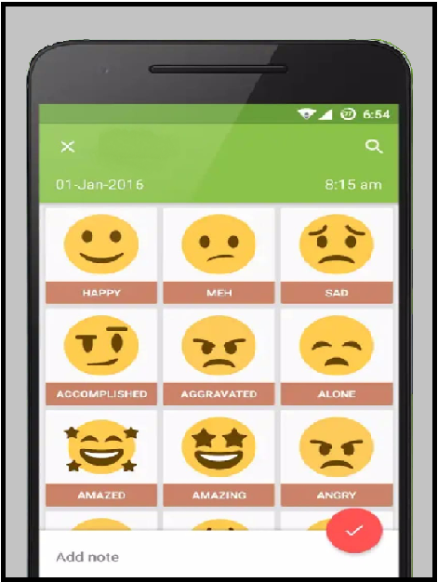

Following a short survey related to the above-named apps, approximately 65% of users are focuses on the design of the apps and 35% are more concerned about the functionality. In the user’s opinion the design must be kept simple and suit the needs, meaning, to track an emotion at a specific moment. Extra implementations in design with no extra functionality tends to make users uncomfortable. The users concerned with the functionality are requesting more flexibility in terms of programmable options, setting a time when the emotions should be measured, gaining options to view logs according to location and to the state of an emotion and being able to input several emotions at one attempt.

### Target Platform Choice

The application is designed to be fully functional on most platforms starting with desktop computers, laptops, tablets and wearables

The specific platform for which the application was created is targeting the mobile devices platform. Although, the app will be fully functional on most devices, due to the specificity of the operating systems that will acquire location, date, time, the app is designed to capture the state of the user’s emotions in different locations. According to books concentrated in profiling an individual’s emotions, triggers are needed to modify a current state of emotion.

Allowing the app to run on a portable device such as a mobile phone will allow the user to experiment different types of emotion triggers with a different outcome in different locations. Improved emotion profiles can be constructed around the triggers distorting the current emotion and creating a new one.

In case of desktop computers there is a high possibility to encounter an emotional pattern arising with the fixed location of the device that will eventually eliminate all the triggers that could possibly modify a state of emotion.

Wearable devices will limit the capabilities of the app. On a wearable device the app will fully functional, but due to the limitations of a wearable’s text input, users will struggle to define and input the emotional triggers, an attribute capable of downsizing the app.

### Implementation Platform Choice

The application is being developed in Intellij IDEA, a development environment, JAVA integrated, developed by JetBrains. Provides features such as code completion, code refactoring and direct access of the databases from the IDE. Numerous plugins are supported that can add functionality to the IDE. It supports several programming languages such as Java, Groovy, Python, JavaScript and HTML. It also supports several frameworks such as Android, Gradle, JavaFX, TestNG. The app will be written in an Android framework as its initial design is set towards a mobile platform.

Among other platforms researched for the development of the app, Android Studio, Ionic, and OutSystems have been studied before considering a specific platform implementation.

Android Studio is a powerful development environment for Android operating systems and precisely created for Android applications development. Highly complex software with the capability of developing applications for internet connected devices, vehicle software interfaces, gaming products and wearables. A major problem of the software is the functionality on an intel chipset portable device, laptop with virtualisation technology; along with the android emulator it will drain all the resources of the machine making it difficult for the user to complete a task without any impediments.

Ionic and OutSystems application development platforms are top rated developing platforms implemented to build Progressive Web Apps and high-performance mobile apps using framework such as HTML, CSS, JAVASCIPT that offer speed, low code, full stack visual deployment, automatic refactoring and architecture that scales. Due to the complexity of the platforms, extra training and experience gathering is required to build o solid base in understanding and becoming familiar with the platform before actually starting to code.

### App Design

The user interface of an application represents everything that a user can see and interact with. In this specific case, User Interface components are provided by Android to allow the build of graphical interfaces for different applications.

The application is structured in different activities.

The first *Activity* of the app will be a *Log In* screen. This will allow the user to have the data on hand if the device will be upgraded, switched. *Views* as *Email* and *Password* fields will be included along with a *Sign In* button that will allow the user, with specific credentials to navigate to the next activity. A *view* is a widget that displays something in android development.

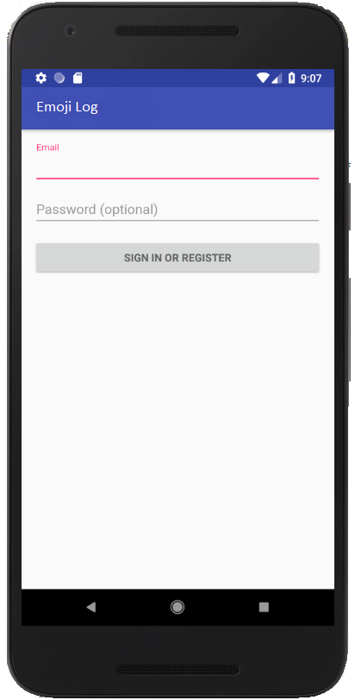

After signing in, the user will view a new page, activity that will allow him to chose between starting a new log or viewing the previous logs.

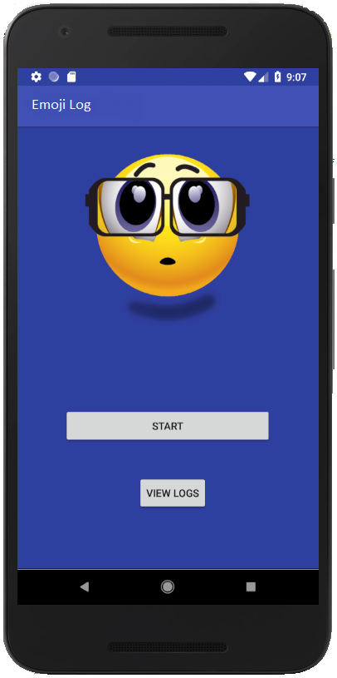

The UI will be kept to a minimum. Simple widgets, like buttons and images, will guide the user to complete the task. Simple Android *Toast pop-up* methods will be used to guide the user throughout the application. A *Toast* method is defined as a view that contains a message for the user.

A Google Map will be implemented in the app which will allow the user to view the current location and save the location data along with the data imputed by the user.

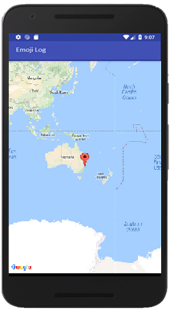

Once the location has been set the user will be guided to another activity, a view populated with widgets, image buttons, simplifying the user access and input of additional data. An edit text widget will be available to give the user the flexibility of adding extra data to complete the selection.

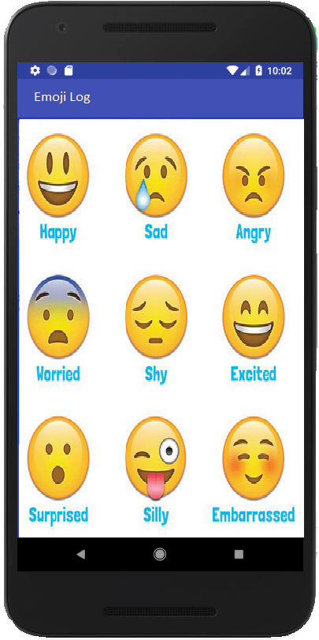

An *Edit Text* widget is an element of the User Interface for entering and modifying a text.

After selection, the app will display the data inputted by the user and will store the data into a local database, constructing a graphical representation of the input taken from the user and display it at request as a graphical representation, once the user has tapped the *View Logs* button in the main activity of the application.

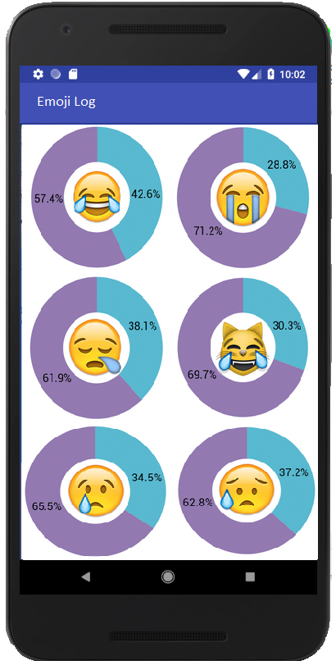

Considering the building blocks of an android application there are different types of components to be named in the creation of the app:

- activities; represented by a single screen containing a user interface,

- services; will allow the data to be synchronised in the background, will be used for building the graphical data,

- broadcast receivers; Toast messages are implemented,

- content providers; will manage the app’s data to be stored in an SQLite database.

The components above are activated by *Intents,* which define an action to be performed.

# References

Allin, P., 2014. *Measuring Wellbeing in Modern Societies.* [Online]   
Available at: http://onlinelibrary.wiley.com/doi/10.1002/9781118539415.wbwell035/abstract  
[Accessed 14 10 2018].

Anon., 2017. *Developers: Android.* [Online]   
Available at: https://developer.android.com/guide/components/fundamentals  
[Accessed 24 October 2018].

Anon., . *mHealth initiatives - WHO.* [Online]   
Available at: http://www.who.int/goe/publications/goe_mhealth_web.pdf  
[Accessed 14 10 2018].

Böck, H., 2012. *IntelliJ IDEA and the NetBeans Platform.* [Online]   
Available at: https://link.springer.com/chapter/10.1007/978-1-4302-4102-7_40  
[Accessed 16 10 2018].

Cl, V., 2014. Mobile devices and apps for health care professionals: uses and benefits.. *P & T : a peer-reviewed journal for formulary management,* , 39(5), pp. 356-364.

Donker, T. et al., 2013. Smartphones for smarter delivery of mental health programs: A systematic review. *Journal of Medical Internet Research,* , 15(11), p. .

España, S. et al., 2006. *Linking requirements specification with interaction design and implementation.* [Online]   
Available at: http://personales.upv.es/jopana/files/books/linking_requirements.pdf  
[Accessed 14 10 2018].

Glinz, M., 2007. On Non-Functional Requirements. *Requirements Engineering,* , (), pp. 21-26.

Schoper, Y. & Heimgärtner, R., 2013. *Lessons from intercultural project management for the intercultural HCI design process.* [Online]   
Available at: https://link.springer.com/content/pdf/10.1007/978-3-642-39241-2_12.pdf  
[Accessed 15 10 2018].

Welie, M. v., Veer, G. v. d. & Eliëns, A., 2001. *Patterns as Tools for User Interface Design.* [Online]   
Available at: https://link.springer.com/chapter/10.1007/978-1-4471-0279-3_30  
[Accessed 15 10 2018].

# 